## SUPPLEMENTARY MATERIALS

A.FILLER SENTENCES 1

B. MODEL RESULTS 4

Model estimates for total sentence reading times 4

Model estimates for eye tracking measures in the pre-critical region (adverbial) 4

Model estimates for eye tracking measures in the critical region I (subject) 6

Model estimates for eye tracking measures in the critical region II (verb) 8

Model estimates for eye tracking measures in the post-critical region (object) 10

Model estimates for eye tracking measures in the wrap-up region (adverbial) 12

C. POST-HOC ANALYSIS OF COLLAPSED CRITICAL REGIONS 14

Model estimates for post-hoc analysis of collapsed subject-verb region 14

Overview of effects in critical regions and collapsed region 16

D. FIGURES 17

# A.FILLER SENTENCES

Below is a list of all filler items. Half of the fillers contain various types of morphological anomalies (*underlined).

1. Nede ved vannet ser Morten *et elg. ‘Down by the water, Morten sees an elk.’ (*The article is neuter gender instead of masculine, *en*).
2. På skolen syr jenta en jakke til hunden. ‘At school, the girl makes a jacket for the dog.’
3. I Trondheim kjører Linda på sparkesykkel hver helg . ‘In Trondheim, Linda rides a kick scooter every weekend.’
4. I skogen løper Karin ofte med venninner. ‘In the forest, Karin often jog with friends.’
5. I *en sjøen fanger Øystein masse laks. ‘In a/the (?) lake, Øystein catches lots of salmon.’ (*Both the indefinite article *en* and the suffix –*en* denoting definite form is used simultaneously).
6. Mandag den 8. november åpner den nye *butikk i sentrum. ‘Monday the 8th of November, the new store opens in the city centre.’ (*The suffix -*en* denoting definite form is missing).
7. Etter skitur bestiller skitreneren takeaway til kveldsmat. ‘After the ski tour, the ski instructor orders take away for dinner.
8. Stort sett *hvert helg drikker Steinar cider på et utested. ‘Almost every weekend, Steinar drinks cider in a bar.’ (The determiner has a suffix *-t* denoting neuter gender instead of masculine, *hver*).
9. På onsdager kjøper mannen kaker til hele familien *sitt. ‘On Wednesdays, the man buys cakes for his whole family.’ (*The determiner is neuter gender, and not masculine: *sin*).
10. Neste uke feirer jenta bursdag hos en venninne. ‘Next week, the girl celebrates her birthday at a friend’s house.’
11. Hvis det regner, sykler ikke Bjørn til universitetet. ‘If it rains, Bjørn does not bike to the university.’
12. Når klassen skal på tur, planlegger læreren turen godt på forhånd. ‘When the class is going on excursion, the teacher plans the trip well in advance.’
13. Selv om pappa mosjonerer hver *dager, går han ikke ned i vekt. ‘Even though dad excercises every days, he does not lose weight.’ (*The plural form of the noun is used instead of singular *dag*).
14. Podcast hører Espen alltid på om morgenen. ‘Podcasts, Espen always listens to in the morning.’
15. Sjokoladekake fra bakeriet elsker mannen. ‘Chocolate cake from the bakery, the man loves.’
16. Maraton løper Einar *hver år i juni. ‘Marathon, Einer runs every year in June. (*The determiner, now in its masculine/feminine form, is missing the neuter suffix -*t*).
17. Bilen blir angrepet av *et grizzlybjørn 100 meter fra hytta. ‘The car is attacked by a grizzly bear 100 meters from the cabin.’ (*The article is neuter gender instead of masculine, *en*).
18. Kanelbollen blir spist av gutten på *kjøkkenen. ‘The cinnamon bun is eaten by the boy in the kitchen.’ (*The masculine suffix *-en* is used instead of the neuter *-et* to denote definite form of the noun).
19. Kaffen blir drukket av en hipster på kaféen. ‘The coffee is drunk by a hipster in the cafe.’
20. Hunden blir sett på gata i Oslo. ‘The dog is seen in the street in Oslo.’
21. Jenta blir sur fordi faren hennes er *kleint på bussen. ‘The girl gets angry because her father is annoying on the bus.’ (*The neuter form of the adjective, with the suffix *-t*, is used instead of the masculine form *klein*).
22. Turid blir glad fordi solen skinner utenfor. ‘Turid becomes happy because the sun is shining outside.’
23. Mekanikeren reparerer kun bilen sin når været er *god. ‘The mechanic only fixes his car when the weather is nice.’ (*The adjective, now in its masculine/feminine form, is missing a neuter suffix *-t*).
24. Inger hekler om *kveldet selv om hun er trøtt. ‘Inger crochets in the evening even thoug she is tired.’ (*The neuter suffix *-et* is used instead of the masculine *-en* to denote definite form of the noun).
25. Tanten hennes, som bor i Trondheim, elsker opera. ‘Her aunt, who lives in Trondheim, loves opera.’
26. Terje, som er glad i mat, arbeider som *kokker på en restaurant. ‘Terje, who loves food, works as a chefs in a restaurant.’ (*The plural form os the noun is used instead of the singular *kok*).
27. Jenta, som går i barnehage, er alltid *glade. ‘The girl, who goes to kindergarten, is always happy.’ (*The plural form of the adjective is used instead of the singular form *glad*).
28. Anita, som er meget aktiv, investerer penger i aksjer hver måned. ‘Anita, who is very active, invests money in stocks every month.’
29. Det er kaféen som er populær. ‘It is the cafe which is popular.’
30. Det er lillesøster som tegner på bordet. ‘It is little sister who is drawing on the table.’
31. Det er gutten som reparerer den *fin stolen på verkstedet. ‘It is the boy who is reparing the nice chair in the workshop.’ (*The indefinite form of the adjective is used instead of the definite form with *-e*).
32. Det er Bjørg som går ned en halv kilo i uken. ‘It is Bjørg who is losing half a kilo a week.’
33. Bestemor syr *flott klær til hele familien. ‘Grandmother makes nice clothes for the whole family.’ (*The singular form of the adjective is used instead of the plural form with *-e*).
34. Bente mosjonerer i skogen på onsdager. ‘Bente excercises in the forest on Wednesdays.’
35. Frode planlegger *et hyttetur med vennene sine. ‘Frode is planning a cottage trip with his friends.’ (*The article is neuter gender instead of masculine, *en*).
36. Legen går på skøyter to ganger i uken. ‘The doctor goes ice skating twice a week.’
37. Maria går på kino i helgen. ‘Maria goes to the cinema in the weekend.’
38. Bjørnen fisker ørret i *et vannet i skogen. ‘The bear catches trout in a/the (?) lake in the forest.’ (*Both the indefinite article *et* and the suffix -*et* denoting definite form is used simultaneously).
39. Gartneren luker *ugresser hver måned om sommeren. ‘The gardener weeds every month during the summer.’ (*The plural form of the noun is *ugress*, without the plural suffix *-er*).
40. Plenklipperen klipper automatisk *gressen i hagen hver uke. ‘The lawn mowerautomatically cuts the grass in the garden every week.’ (*The masculine suffix *-en* is used instead of the neuter *-et* to denote definite form of the noun).

# B. MODEL RESULTS

## Model estimates for total sentence reading times

Table 6. Model estimates for total sentence reading times in ms

|  |  |  |  |  |
| --- | --- | --- | --- | --- |
| **Random effects** | **Variance** | **Std. Dev.** |  |  |
| Participant (Intercept) | 558973 | 747.6 |  |  |
| Item (Intercept) | 76336 | 276.3 |  |  |
| Residual | 533671 | 730.5 |  |  |
| **Fixed effects** | **Estimate** | **Std. Error** | ***t*-value** | ***p*-value** |
| (Intercept) | 2875.377 | 121.477 | 23.670 | < 2e-16 *** |
| GRAM | 409.925 | 69.746 | 5.877 | 4.97e-09 *** |
| LENGTH | 749.937 | 34.036 | 22.033 | < 2e-16 *** |
| TRIAL | -15.012 | 1.530 | -9.812 | < 2e-16 *** |
| GRAM:LENGTH | -24.326 | 68.214 | -0.357 | 0.721431 |
| GRAM:TRIAL | -11.022 | 3.075 | -3.584 | 0.000347 *** |

## Model estimates for eye tracking measures in the pre-critical region (adverbial)

Table 7. Model estimates, first fixation duration in ms (pre-critical region)

|  |  |  |  |  |
| --- | --- | --- | --- | --- |
| **Random effects** | **Variance** | **Std. Dev.** |  |  |
| Participant (Intercept) | 479.37 | 21.89 |  |  |
| Item (Intercept) | 35.04 | 5.92 |  |  |
| Residual | 4131.69 | 64.28 |  |  |
| **Fixed effects** | **Estimate** | **Std. Error** | ***t*-value** | ***p*-value** |
| (Intercept) | 177.7608 | 4.5557 | 39.020 | < 2e-16 *** |
| GRAM | 6.4307 | 6.2977 | 1.021 | 0.30734 |
| LENGTH | -8.2289 | 3.0684 | -2.682 | 0.00739 ** |
| TRIAL | 0.1178 | 0.1381 | 0.853 | 0.39378 |
| GRAM:LENGTH | -6.4615 | 6.1343 | -1.053 | 0.29233 |
| GRAM:TRIAL | -0.1437 | 0.2761 | -0.520 | 0.60285 |

Table 8. Model estimates, gaze duration (pre-critical region)

|  |  |  |  |  |
| --- | --- | --- | --- | --- |
| **Random effects** | **Variance** | **Std. Dev.** |  |  |
| Participant (Intercept) | 36796 | 191.82 |  |  |
| Item (Intercept) | 6562 | 81.01 |  |  |
| Residual | 60948 | 246.88 |  |  |
| **Fixed effects** | **Estimate** | **Std. Error** | ***t*-value** | ***p*-value** |
| (Intercept) | 726.870 | 32.822 | 22.146 | < 2e-16 *** |
| GRAM | 29.803 | 24.330 | 1.225 | 0.2208 |
| LENGTH | 649.976 | 11.802 | 55.073 | < 2e-16 *** |
| TRIAL | -1.368 | 0.532 | -2.571 | 0.0102 * |
| GRAM:LENGTH | -17.877 | 23.599 | -0.758 | 0.4488 |
| GRAM:TRIAL | -1.233 | 1.069 | -1.154 | 0.2489 |

Table 9. Model estimates, regression path duration (pre-critical region)

|  |  |  |  |  |
| --- | --- | --- | --- | --- |
| **Random effects** | **Variance** | **Std. Dev.** |  |  |
| Participant (Intercept) | 36737 | 191.7 |  |  |
| Item (Intercept) | 6528 | 80.8 |  |  |
| Residual | 60809 | 246.6 |  |  |
| **Fixed effects** | **Estimate** | **Std. Error** | ***t*-value** | ***p*-value** |
| (Intercept) | 728.0229 | 32.7855 | 22.206 | < 2e-16 *** |
| GRAM | 32.2441 | 24.3017 | 1.327 | 0.18474 |
| LENGTH | 650.1281 | 11.7885 | 55.150 | < 2e-16 *** |
| TRIAL | -1.4108 | 0.5314 | -2.655 | 0.00801 ** |
| GRAM:LENGTH | -17.5830 | 23.5715 | -0.746 | 0.45580 |
| GRAM:TRIAL | -1.3255 | 1.0674 | -1.242 | 0.21448 |

Table 10. Model estimates, total duration (pre-critical region)

|  |  |  |  |  |
| --- | --- | --- | --- | --- |
| **Random effects** | **Variance** | **Std. Dev.** |  |  |
| Participant (Intercept) | 77812 | 278.95 |  |  |
| Item (Intercept) | 9404 | 96.97 |  |  |
| Residual | 158157 | 397.69 |  |  |
| **Fixed effects** | **Estimate** | **Std. Error** | ***t*-value** | ***p*-value** |
| (Intercept) | 924.2121 | 47.0358 | 19.649 | < 2e-16 *** |
| GRAM | 149.4711 | 37.9209 | 3.942 | 8.41e-05 *** |
| LENGTH | 780.9166 | 18.5271 | 42.150 | < 2e-16 *** |
| TRIAL | -3.7648 | 0.8323 | -4.524 | 6.49e-06 *** |
| GRAM:LENGTH | -1.0636 | 37.1209 | -0.029 | 0.97715 |
| GRAM:TRIAL | -4.3122 | 1.6711 | -2.580 | 0.00995 ** |

Table 11. Model estimates, first-pass skipping ratio (pre-critical region)

|  |  |  |  |  |
| --- | --- | --- | --- | --- |
| **Random effects** | **Variance** | **Std. Dev.** |  |  |
| Participant (Intercept) | 2.5903 | 1.6095 |  |  |
| Item (Intercept) | 0.6542 | 0.8088 |  |  |
| **Fixed effects** | **Estimate** | **Std. Error** | ***z*-value** | ***p*-value** |
| (Intercept) | -8.4905 | 32.0664 | -0.265 | 0.7912 |
| GRAM | 7.9819 | 64.1256 | 0.124 | 0.9009 |
| LENGTH | -10.9765 | 64.1277 | -0.171 | 0.8641 |
| TRIAL (rescaled) | -1.0604 | 0.4762 | -2.227 | 0.0259 * |
| GRAM:LENGTH | 16.3876 | 128.2511 | 0.128 | 0.8983 |

Since the model would not converge, the interaction between grammar and trial was removed. The optimizer BOBYQA was used as well.

## Model estimates for eye tracking measures in the critical region I (subject)

Table 12. Model estimates, first fixation duration in ms (critical region I, subject)

|  |  |  |  |  |
| --- | --- | --- | --- | --- |
| **Random effects** | **Variance** | **Std. Dev.** |  |  |
| Participant (Intercept) | 1001.9 | 31.65 |  |  |
| Item (Intercept) | 147.8 | 12.16 |  |  |
| Residual | 4854.7 | 69.68 |  |  |
| **Fixed effects** | **Estimate** | **Std. Error** | ***t*-value** | ***p*-value** |
| (Intercept) | 230.2834 | 6.0435 | 38.104 | < 2e-16 *** |
| GRAM | 6.7504 | 6.9281 | 0.974 | 0.3300 |
| LENGTH | 8.1628 | 3.3909 | 2.407 | 0.0162 * |
| TRIAL | -0.2346 | 0.1520 | -1.544 | 0.1228 |
| GRAM:LENGTH | 11.4659 | 6.7839 | 1.690 | 0.0912 |
| GRAM:TRIAL | 0.3604 | 0.3046 | 1.183 | 0.2368 |

Table 13. Model estimates, gaze duration in ms (critical region I, subject)

|  |  |  |  |  |
| --- | --- | --- | --- | --- |
| **Random effects** | **Variance** | **Std. Dev.** |  |  |
| Participant (Intercept) | 2845 | 53.34 |  |  |
| Item (Intercept) | 2632 | 51.30 |  |  |
| Residual | 13934 | 118.04 |  |  |
| **Fixed effects** | **Estimate** | **Std. Error** | ***t*-value** | ***p*-value** |
| (Intercept) | 283.2806 | 12.6286 | 22.432 | < 2e-16 *** |
| GRAM | 46.6087 | 11.7717 | 3.959 | 7.84e-05 *** |
| LENGTH | -0.2837 | 5.7484 | -0.049 | 0.9607 |
| TRIAL | -0.6614 | 0.2579 | -2.565 | 0.0104 * |
| GRAM:LENGTH | 3.2586 | 11.5013 | 0.283 | 0.7770 |
| GRAM:TRIAL | -0.2153 | 0.5180 | -0.416 | 0.6778 |

Table 14. Model estimates, regression path duration in ms (critical region I, subject)

|  |  |  |  |  |
| --- | --- | --- | --- | --- |
| **Random effects** | **Variance** | **Std. Dev.** |  |  |
| Participant (Intercept) | 7516 | 86.69 |  |  |
| Item (Intercept) | 4935 | 70.25 |  |  |
| Residual | 49229 | 221.88 |  |  |
| **Fixed effects** | **Estimate** | **Std. Error** | ***t*-value** | ***p*-value** |
| (Intercept) | 372.5903 | 20.0359 | 18.596 | <2e-16 *** |
| GRAM | 149.4993 | 22.1085 | 6.762 | 1.89e-11 *** |
| LENGTH | -27.9815 | 10.8021 | -2.590 | 0.00967 ** |
| TRIAL | -2.2105 | 0.4845 | -4.563 | 5.42e-06 *** |
| GRAM:LENGTH | -21.5756 | 21.6121 | -0.998 | 0.31828 |
| GRAM:TRIAL | -2.2828 | 0.9727 | -2.347 | 0.01904 * |

Table 15. Model estimates, total duration in ms (critical region I, subject)

|  |  |  |  |  |
| --- | --- | --- | --- | --- |
| **Random effects** | **Variance** | **Std. Dev.** |  |  |
| Participant (Intercept) | 9321 | 96.55 |  |  |
| Item (Intercept) | 7573 | 87.02 |  |  |
| Residual | 35819 | 189.26 |  |  |
| **Fixed effects** | **Estimate** | **Std. Error** | ***t*-value** | ***p*-value** |
| (Intercept) | 387.4995 | 21.5467 | 17.984 | < 2e-16 *** |
| GRAM | 170.7236 | 18.0732 | 9.446 | < 2e-16 *** |
| LENGTH | -13.0142 | 8.8177 | -1.476 | 0.140146 |
| TRIAL | -2.2524 | 0.3963 | -5.683 | 1.54e-08 *** |
| GRAM:LENGTH | -29.2804 | 17.6731 | -1.657 | 0.097742 |
| GRAM:TRIAL | -2.9220 | 0.7969 | -3.667 | 0.000253 *** |

Table 16. Model estimates, first-pass skipping ratio (critical region I, subject)

|  |  |  |  |  |
| --- | --- | --- | --- | --- |
| **Random effects** | **Variance** | **Std. Dev.** |  |  |
| Participant (Intercept) | 1.5101 | 1.2289 |  |  |
| Item (Intercept) | 0.2826 | 0.5316 |  |  |
| **Fixed effects** | **Estimate** | **Std. Error** | ***z*-value** | ***p*-value** |
| (Intercept) | -3.0275 | 0.3013 | -10.048 | < 2e-16 *** |
| GRAM | 0.2371 | 0.3725 | 0.637 | 0.524 |
| LENGTH | 0.1259 | 0.1855 | 0.679 | 0.497 |
| TRIAL (rescaled) | -0.2294 | 0.3339 | -0.687 | 0.492 |
| GRAM:LENGTH | -0.4488 | 0.3760 | -1.194 | 0.233 |
| GRAM:TRIAL | -0.8462 | 0.6716 | -1.260 | 0.208 |

Table 17. Model estimates, first-pass regression ratio (critical region I, subject)

|  |  |  |  |  |
| --- | --- | --- | --- | --- |
| **Random effects** | **Variance** | **Std. Dev.** |  |  |
| Participant (Intercept) | 0.3944 | 0.6280 |  |  |
| Item (Intercept) | 0.2018 | 0.4492 |  |  |
| **Fixed effects** | **Estimate** | **Std. Error** | ***z*-value** | ***p*-value** |
| (Intercept) | -2.07715 | 0.20200 | -10.283 | < 2e-16 *** |
| GRAM | 1.12744 | 0.31894 | 3.535 | 0.000408 *** |
| LENGTH | -0.28370 | 0.16219 | -1.749 | 0.080256 |
| TRIAL (rescaled) | -0.45080 | 0.28771 | -1.567 | 0.117151 |
| GRAM:LENGTH | -0.06884 | 0.32393 | -0.213 | 0.831694 |
| GRAM:TRIAL | -0.54672 | 0.57543 | -0.950 | 0.342054 |

## Model estimates for eye tracking measures in the critical region II (verb)

Table 18. Model estimates, first fixation duration in ms (critical region II, verb)

|  |  |  |  |  |
| --- | --- | --- | --- | --- |
| **Random effects** | **Variance** | **Std. Dev.** |  |  |
| Participant (Intercept) | 1242.05 | 35.243 |  |  |
| Item (Intercept) | 33.84 | 5.817 |  |  |
| Residual | 6514.73 | 80.714 |  |  |
| **Fixed effects** | **Estimate** | **Std. Error** | ***t*-value** | ***p*-value** |
| (Intercept) | 238.1546 | 6.5218 | 36.517 | < 2e-16 *** |
| GRAM | 22.5873 | 7.9474 | 2.842 | 0.00454 ** |
| LENGTH | 12.0798 | 3.8742 | 3.118 | 0.00185 ** |
| TRIAL | -0.1508 | 0.1746 | -0.864 | 0.38780 |
| GRAM:LENGTH | 0.2275 | 7.7457 | 0.029 | 0.97657 |
| GRAM:TRIAL | -0.4458 | 0.3491 | -1.277 | 0.20187 |

Table 19. Model estimates, gaze duration in ms (critical region II, verb)

|  |  |  |  |  |
| --- | --- | --- | --- | --- |
| **Random effects** | **Variance** | **Std. Dev.** |  |  |
| Participant (Intercept) | 2588.7 | 50.88 |  |  |
| Item (Intercept) | 247.1 | 15.72 |  |  |
| Residual | 12643.1 | 112.44 |  |  |
| **Fixed effects** | **Estimate** | **Std. Error** | ***t*-value** | ***p*-value** |
| (Intercept) | 278.8768 | 9.5329 | 29.254 | < 2e-16 *** |
| GRAM | 32.6015 | 11.1027 | 2.936 | 0.00337 ** |
| LENGTH | 5.1584 | 5.3988 | 0.955 | 0.33948 |
| TRIAL | -0.3599 | 0.2436 | -1.477 | 0.13979 |
| GRAM:LENGTH | 2.8138 | 10.7962 | 0.261 | 0.79441 |
| GRAM:TRIAL | -0.9459 | 0.4883 | -1.937 | 0.05288 |

Table 20. Model estimates, regression path duration in ms (critical region II, verb)

|  |  |  |  |  |
| --- | --- | --- | --- | --- |
| **Random effects** | **Variance** | **Std. Dev.** |  |  |
| Participant (Intercept) | 5344.9 | 73.11 |  |  |
| Item (Intercept) | 452.4 | 21.27 |  |  |
| Residual | 57486.2 | 239.76 |  |  |
| **Fixed effects** | **Estimate** | **Std. Error** | ***t*-value** | ***p*-value** |
| (Intercept) | 401.4608 | 16.1897 | 24.797 | < 2e-16 *** |
| GRAM | 161.6043 | 23.6185 | 6.842 | 1.09e-11 *** |
| LENGTH | -1.7611 | 11.5067 | -0.153 | 0.878375 |
| TRIAL | -2.6121 | 0.5186 | -5.037 | 5.24e-07 *** |
| GRAM:LENGTH | 22.1857 | 23.0086 | 0.964 | 0.335069 |
| GRAM:TRIAL | -3.4970 | 1.0379 | -3.369 | 0.000771 *** |

Table 21. Model estimates, total duration in ms (critical region II, verb)

|  |  |  |  |  |
| --- | --- | --- | --- | --- |
| **Random effects** | **Variance** | **Std. Dev.** |  |  |
| Participant (Intercept) | 6978.6 | 83.54 |  |  |
| Item (Intercept) | 902.5 | 30.04 |  |  |
| Residual | 29997.5 | 173.20 |  |  |
| **Fixed effects** | **Estimate** | **Std. Error** | ***t*-value** | ***p*-value** |
| (Intercept) | 368.4372 | 15.3435 | 24.013 | < 2e-16 *** |
| GRAM | 88.0624 | 16.4911 | 5.340 | 1.05e-07 *** |
| LENGTH | 0.3660 | 8.0677 | 0.045 | 0.96382 |
| TRIAL | -1.6012 | 0.3622 | -4.421 | 1.04e-05 *** |
| GRAM:LENGTH | 15.9832 | 16.1593 | 0.989 | 0.32275 |
| GRAM:TRIAL | -2.4024 | 0.7264 | -3.307 | 0.00096 *** |

Table 22. Model estimates, first-pass skipping ratio (critical region II, verb)

|  |  |  |  |  |
| --- | --- | --- | --- | --- |
| **Random effects** | **Variance** | **Std. Dev.** |  |  |
| Participant (Intercept) | 2.9490 | 1.7173 |  |  |
| Item (Intercept) | 0.1249 | 0.3534 |  |  |
| **Fixed effects** | **Estimate** | **Std. Error** | ***z*-value** | ***p*-value** |
| (Intercept) | -3.81898 | 0.41509 | -9.200 | < 2e-16 *** |
| GRAM | -0.46246 | 0.44455 | -1.040 | 0.298 |
| LENGTH | -0.01809 | 0.22274 | -0.081 | 0.935 |
| TRIAL (rescaled) | -0.38926 | 0.40199 | -0.968 | 0.333 |
| GRAM:LENGTH | -0.38665 | 0.45299 | -0.854 | 0.393 |
| GRAM:TRIAL | 0.52301 | 0.81229 | 0.644 | 0.520 |

Table 23. Model estimates, first-pass regression ratio (critical region II, verb)

|  |  |  |  |  |
| --- | --- | --- | --- | --- |
| **Random effects** | **Variance** | **Std. Dev.** |  |  |
| Participant (Intercept) | 0.26693 | 0.5166 |  |  |
| Item (Intercept) | 0.03104 | 0.1762 |  |  |
| **Fixed effects** | **Estimate** | **Std. Error** | ***z*-value** | ***p*-value** |
| (Intercept) | -1.5538 | 0.1692 | -9.181 | < 2e-16 *** |
| GRAM | 1.1061 | 0.2914 | 3.796 | 0.000147 *** |
| LENGTH | -0.2724 | 0.1542 | -1.767 | 0.077250 |
| TRIAL (rescaled) | -0.9734 | 0.2801 | -3.475 | 0.000511 *** |
| GRAM:LENGTH | 0.4479 | 0.3084 | 1.452 | 0.146476 |
| GRAM:TRIAL | 0.1825 | 0.5596 | 0.326 | 0.744366 |

## Model estimates for eye tracking measures in the post-critical region (object)

Table 24. Model estimates, first fixation duration in ms (post-critical region)

|  |  |  |  |  |
| --- | --- | --- | --- | --- |
| **Random effects** | **Variance** | **Std. Dev.** |  |  |
| Participant (Intercept) | 1138.2 | 33.74 |  |  |
| Item (Intercept) | 326.9 | 18.08 |  |  |
| Residual | 6657.5 | 81.59 |  |  |
| **Fixed effects** | **Estimate** | **Std. Error** | ***t*-value** | ***p*-value** |
| (Intercept) | 244.12372 | 6.88529 | 35.456 | < 2e-16 *** |
| GRAM | -3.01105 | 7.92019 | -0.380 | 0.704 |
| LENGTH | -2.13152 | 3.87091 | -0.551 | 0.582 |
| TRIAL | -0.03601 | 0.17429 | -0.207 | 0.836 |
| GRAM:LENGTH | -10.21189 | 7.74877 | -1.318 | 0.188 |
| GRAM:TRIAL | -0.33795 | 0.35000 | -0.966 | 0.334 |

Table 25. Model estimates, gaze duration in ms (post-critical region)

|  |  |  |  |  |
| --- | --- | --- | --- | --- |
| **Random effects** | **Variance** | **Std. Dev.** |  |  |
| Participant (Intercept) | 5701 | 75.70 |  |  |
| Item (Intercept) | 7805 | 88.34 |  |  |
| Residual | 23313 | 152.68 |  |  |
| **Fixed effects** | **Estimate** | **Std. Error** | ***t*-value** | ***p*-value** |
| (Intercept) | 349.7868 | 19.1919 | 18.226 | < 2e-16 *** |
| GRAM | -6.2397 | 14.8570 | -0.420 | 0.674550 |
| LENGTH | -26.6994 | 7.2452 | -3.685 | 0.000236 *** |
| TRIAL | -0.5049 | 0.3266 | -1.546 | 0.122270 |
| GRAM:LENGTH | -26.7907 | 14.5076 | -1.847 | 0.064969 |
| GRAM:TRIAL | -0.2497 | 0.6570 | -0.380 | 0.703943 |

Table 26. Model estimates, regression path duration in ms (post-critical region)

|  |  |  |  |  |
| --- | --- | --- | --- | --- |
| **Random effects** | **Variance** | **Std. Dev.** |  |  |
| Participant (Intercept) | 7454 | 86.34 |  |  |
| Item (Intercept) | 10790 | 103.88 |  |  |
| Residual | 64631 | 254.23 |  |  |
| **Fixed effects** | **Estimate** | **Std. Error** | ***t*-value** | ***p*-value** |
| (Intercept) | 422.4931 | 23.9980 | 17.605 | < 2e-16 *** |
| GRAM | 18.7818 | 24.7191 | 0.760 | 0.44747 |
| LENGTH | -34.3612 | 12.0618 | -2.849 | 0.00444 ** |
| TRIAL | -1.1531 | 0.5434 | -2.122 | 0.03398 * |
| GRAM:LENGTH | -57.3454 | 24.1506 | -2.374 | 0.01768 * |
| GRAM:TRIAL | -0.8285 | 1.0929 | -0.758 | 0.44851 |

Table 27. Model estimates, total duration in ms (post-critical region)

|  |  |  |  |  |
| --- | --- | --- | --- | --- |
| **Random effects** | **Variance** | **Std. Dev.** |  |  |
| Participant (Intercept) | 14619 | 120.9 |  |  |
| Item (Intercept) | 13784 | 117.4 |  |  |
| Residual | 43283 | 208.0 |  |  |
| **Fixed effects** | **Estimate** | **Std. Error** | ***t*-value** | ***p*-value** |
| (Intercept) | 464.1927 | 27.3271 | 16.987 | < 2e-16 *** |
| GRAM | -12.0881 | 19.8730 | -0.608 | 0.543 |
| LENGTH | -15.7605 | 9.6932 | -1.626 | 0.104 |
| TRIAL | -2.1637 | 0.4357 | -4.965 | 7.51e-07 *** |
| GRAM:LENGTH | -27.2042 | 19.4291 | -1.400 | 0.162 |
| GRAM:TRIAL | -0.5737 | 0.8764 | -0.655 | 0.513 |

Table 28. Model estimates, first-pass skipping ratio (post-critical region)

|  |  |  |  |  |
| --- | --- | --- | --- | --- |
| **Random effects** | **Variance** | **Std. Dev.** |  |  |
| Participant (Intercept) | 2.453 | 1.566 |  |  |
| Item (Intercept) | 2.104 | 1.451 |  |  |
| **Fixed effects** | **Estimate** | **Std. Error** | ***z*-value** | ***p*-value** |
| (Intercept) | -5.6856 | 0.6190 | -9.185 | < 2e-16 *** |
| GRAM | 0.2087 | 0.6436 | 0.324 | 0.7457 |
| LENGTH | 0.2541 | 0.2927 | 0.868 | 0.3852 |
| TRIAL (rescaled) | 1.0681 | 0.5451 | 1.959 | 0.0501 |
| GRAM:LENGTH | 0.4985 | 0.6276 | 0.794 | 0.4270 |
| GRAM:TRIAL | -0.1362 | 1.0616 | -0.128 | 0.8979 |

Table 29. Model estimates, first-pass regression ratio (post-critical region)

|  |  |  |  |  |
| --- | --- | --- | --- | --- |
| **Random effects** | **Variance** | **Std. Dev.** |  |  |
| Participant (Intercept) | 0.2056 | 0.4534 |  |  |
| Item (Intercept) | 0.1427 | 0.3778 |  |  |
| **Fixed effects** | **Estimate** | **Std. Error** | ***z*-value** | ***p*-value** |
| (Intercept) | -2.11818 | 0.18676 | -11.341 | < 2e-16 *** |
| GRAM | 0.24894 | 0.31588 | 0.788 | 0.4307 |
| LENGTH | -0.05718 | 0.16217 | -0.353 | 0.7244 |
| TRIAL (rescaled) | -0.57119 | 0.29355 | -1.946 | 0.0517 |
| GRAM:LENGTH | -0.30082 | 0.32542 | -0.924 | 0.3553 |
| GRAM:TRIAL | -0.20932 | 0.58877 | -0.356 | 0.7222 |

## Model estimates for eye tracking measures in the wrap-up region (adverbial)

Table 30. Model estimates, first fixation duration in ms (wrap-up region)

|  |  |  |  |  |
| --- | --- | --- | --- | --- |
| **Random effects** | **Variance** | **Std. Dev.** |  |  |
| Participant (Intercept) | 2296.4 | 47.92 |  |  |
| Item (Intercept) | 423.2 | 20.57 |  |  |
| Residual | 12269.5 | 110.77 |  |  |
| **Fixed effects** | **Estimate** | **Std. Error** | ***t*-value** | ***p*-value** |
| (Intercept) | 270.8234 | 9.2838 | 29.172 | < 2e-16 *** |
| GRAM | -8.6469 | 10.5794 | -0.817 | 0.414 |
| LENGTH | -1.8581 | 5.1741 | -0.359 | 0.720 |
| TRIAL | -0.2279 | 0.2323 | -0.981 | 0.327 |
| GRAM:LENGTH | -0.0949 | 10.3644 | -0.009 | 0.993 |
| GRAM:TRIAL | 0.3049 | 0.4661 | 0.654 | 0.513 |

Table 31. Model estimates, gaze duration in ms (wrap-up region)

|  |  |  |  |  |
| --- | --- | --- | --- | --- |
| **Random effects** | **Variance** | **Std. Dev.** |  |  |
| Participant (Intercept) | 32051 | 179.0 |  |  |
| Item (Intercept) | 18518 | 136.1 |  |  |
| Residual | 67280 | 259.4 |  |  |
| **Fixed effects** | **Estimate** | **Std. Error** | ***t*-value** | ***p*-value** |
| (Intercept) | 631.6596 | 35.8227 | 17.633 | < 2e-16 *** |
| GRAM | -20.7221 | 24.8454 | -0.834 | 0.4044 |
| LENGTH | -20.2776 | 12.1192 | -1.673 | 0.0945 |
| TRIAL | -3.7880 | 0.5448 | -6.952 | 5.04e-12 *** |
| GRAM:LENGTH | -5.6171 | 24.2921 | -0.231 | 0.8172 |
| GRAM:TRIAL | 0.8911 | 1.0957 | 0.813 | 0.4162 |

Table 32. Model estimates, regression path duration in ms (wrap-up region)

|  |  |  |  |  |
| --- | --- | --- | --- | --- |
| **Random effects** | **Variance** | **Std. Dev.** |  |  |
| Participant (Intercept) | 149799 | 387.0 |  |  |
| Item (Intercept) | 22218 | 149.1 |  |  |
| Residual | 332035 | 576.2 |  |  |
| **Fixed effects** | **Estimate** | **Std. Error** | ***t*-value** | ***p*-value** |
| (Intercept) | 1037.623 | 66.547 | 15.592 | < 2e-16 *** |
| GRAM | 72.722 | 55.111 | 1.320 | 0.187 |
| LENGTH | 138.705 | 26.920 | 5.152 | 2.86e-07 *** |
| TRIAL | -8.721 | 1.209 | -7.210 | 8.25e-13 *** |
| GRAM:LENGTH | 39.346 | 53.940 | 0.729 | 0.466 |
| GRAM:TRIAL | -3.660 | 2.429 | -1.507 | 0.132 |

Table 33. Model estimates, total duration in ms (wrap-up region)

|  |  |  |  |  |
| --- | --- | --- | --- | --- |
| **Random effects** | **Variance** | **Std. Dev.** |  |  |
| Participant (Intercept) | 41910 | 204.7 |  |  |
| Item (Intercept) | 20299 | 142.5 |  |  |
| Residual | 72238 | 268.8 |  |  |
| **Fixed effects** | **Estimate** | **Std. Error** | ***t*-value** | ***p*-value** |
| (Intercept) | 731.3359 | 39.2874 | 18.615 | <2e-16 *** |
| GRAM | 12.4040 | 25.6733 | 0.483 | 0.629 |
| LENGTH | -2.6183 | 12.5227 | -0.209 | 0.834 |
| TRIAL | -5.2596 | 0.5630 | -9.343 | <2e-16 *** |
| GRAM:LENGTH | 15.3464 | 25.1004 | 0.611 | 0.541 |
| GRAM:TRIAL | -0.7581 | 1.1321 | -0.670 | 0.503 |

Table 34. Model estimates, first-pass skipping ratio (wrap-up region)

|  |  |  |  |  |
| --- | --- | --- | --- | --- |
| **Random effects** | **Variance** | **Std. Dev.** |  |  |
| Participant (Intercept) | 4.0888 | 2.0221 |  |  |
| Item (Intercept) | 0.2737 | 0.5232 |  |  |
| **Fixed effects** | **Estimate** | **Std. Error** | ***z*-value** | ***p*-value** |
| (Intercept) | -6.97366 | 1.34224 | -5.196 | 2.04e-07 *** |
| GRAM | 0.88255 | 0.70241 | 1.256 | 0.209 |
| LENGTH | 0.45213 | 0.66106 | 0.684 | 0.494 |
| TRIAL (rescaled) | -0.01681 | 1.14651 | -0.015 | 0.988 |

The model would not converge, when including interactions. Both interactions were thus removed.

Table 35. Model estimates, first-pass regression ratio (wrap-up region)

|  |  |  |  |  |
| --- | --- | --- | --- | --- |
| **Random effects** | **Variance** | **Std. Dev.** |  |  |
| Participant (Intercept) | 1.52616 | 1.2354 |  |  |
| Item (Intercept) | 0.02937 | 0.1714 |  |  |
| **Fixed effects** | **Estimate** | **Std. Error** | ***z*-value** | ***p*-value** |
| (Intercept) | -0.83171 | 0.21641 | -3.843 | 0.000121 *** |
| GRAM | 0.07071 | 0.23384 | 0.302 | 0.762363 |
| LENGTH | 0.40196 | 0.11800 | 3.407 | 0.000658 *** |
| TRIAL (rescaled) | -0.66588 | 0.21266 | -3.131 | 0.001741 ** |
| GRAM:LENGTH | 0.08641 | 0.23547 | 0.367 | 0.713648 |
| GRAM:TRIAL | -0.45728 | 0.42446 | -1.077 | 0.281332 |

# C. POST-HOC ANALYSIS OF COLLAPSED CRITICAL REGIONS

## Model estimates for post-hoc analysis of collapsed subject-verb region

Table 36. Model estimates, first fixation duration in ms (critical regions I+II)

|  |  |  |  |  |
| --- | --- | --- | --- | --- |
| **Random effects** | **Variance** | **Std. Dev.** |  |  |
| Participant (Intercept) | 6024.8 | 77.62 |  |  |
| Item (Intercept) | 414.5 | 20.36 |  |  |
| Residual | 13216.3 | 114.96 |  |  |
| **Fixed effects** | **Estimate** | **Std. Error** | ***t*-value** | ***p*-value** |
| (Intercept) | 454.0856 | 12.8723 | 35.276 | < 2e-16 *** |
| GRAM | 39.5480 | 10.9624 | 3.608 | 0.000318 *** |
| LENGTH | 16.3600 | 5.3594 | 3.053 | 0.002303 ** |
| TRIAL | -0.4575 | 0.2408 | -1.900 | 0.057611 |
| GRAM:LENGTH | 20.3430 | 10.7347 | 1.895 | 0.058246 |
| GRAM:TRIAL | -0.2033 | 0.4829 | -0.421 | 0.673846 |

Table 37. Model estimates, gaze duration in ms (critical regions I+II)

|  |  |  |  |  |
| --- | --- | --- | --- | --- |
| **Random effects** | **Variance** | **Std. Dev.** |  |  |
| Participant (Intercept) | 13339 | 115.50 |  |  |
| Item (Intercept) | 3384 | 58.17 |  |  |
| Residual | 25284 | 159.01 |  |  |
| **Fixed effects** | **Estimate** | **Std. Error** | ***t*-value** | ***p*-value** |
| (Intercept) | 543.3570 | 20.4851 | 26.525 | < 2e-16 *** |
| GRAM | 85.4716 | 15.1996 | 5.623 | 2.17e-08 *** |
| LENGTH | 3.0401 | 7.4141 | 0.410 | 0.68183 |
| TRIAL | -0.9954 | 0.3334 | -2.985 | 0.00287 ** |
| GRAM:LENGTH | 17.3315 | 14.8578 | 1.166 | 0.24357 |
| GRAM:TRIAL | -1.1813 | 0.6702 | -1.763 | 0.07815 |

Table 38. Model estimates, regression path duration in ms (critical regions I+II)

|  |  |  |  |  |
| --- | --- | --- | --- | --- |
| **Random effects** | **Variance** | **Std. Dev.** |  |  |
| Participant (Intercept) | 28999 | 170.29 |  |  |
| Item (Intercept) | 9264 | 96.25 |  |  |
| Residual | 92776 | 304.59 |  |  |
| **Fixed effects** | **Estimate** | **Std. Error** | ***t*-value** | ***p*-value** |
| (Intercept) | 751.2319 | 32.3321 | 23.235 | < 2e-16 *** |
| GRAM | 308.5328 | 29.1039 | 10.601 | < 2e-16 *** |
| LENGTH | -28.7376 | 14.2016 | -2.024 | 0.0432 * |
| TRIAL | -4.7196 | 0.6385 | -7.391 | 2.23e-13 *** |
| GRAM:LENGTH | 21.5764 | 28.4575 | 0.758 | 0.4484 |
| GRAM:TRIAL | -5.5050 | 1.2832 | -4.290 | 1.88e-05 *** |

Table 39. Model estimates, total duration in ms (critical regions I+II)

|  |  |  |  |  |
| --- | --- | --- | --- | --- |
| **Random effects** | **Variance** | **Std. Dev.** |  |  |
| Participant (Intercept) | 31162 | 176.5 |  |  |
| Item (Intercept) | 10714 | 103.5 |  |  |
| Residual | 76250 | 276.1 |  |  |
| **Fixed effects** | **Estimate** | **Std. Error** | ***t*-value** | ***p*-value** |
| (Intercept) | 755.6856 | 32.9995 | 22.900 | < 2e-16 *** |
| GRAM | 258.0955 | 26.3659 | 9.789 | < 2e-16 *** |
| LENGTH | -13.0605 | 12.8685 | -1.015 | 0.31 |
| TRIAL | -3.8282 | 0.5785 | -6.618 | 4.83e-11 *** |
| GRAM:LENGTH | -13.5326 | 25.7897 | -0.525 | 0.60 |
| GRAM:TRIAL | -5.2642 | 1.1629 | -4.527 | 6.39e-06 *** |

Table 40. Model estimates, first-pass skipping ratio (critical regions I+II)

|  |  |  |  |  |
| --- | --- | --- | --- | --- |
| **Random effects** | **Variance** | **Std. Dev.** |  |  |
| Participant (Intercept) | 1.0114 | 1.0057 |  |  |
| Item (Intercept) | 0.2278 | 0.4772 |  |  |
| **Fixed effects** | **Estimate** | **Std. Error** | ***z*-value** | ***p*-value** |
| (Intercept) | -2.98980 | 0.29007 | -10.307 | < 2e-16 *** |
| GRAM | 0.75693 | 0.40980 | 1.847 | 0.0647 |
| LENGTH | 0.02327 | 0.21178 | 0.110 | 0.9125 |
| TRIAL (rescaled) | -0.73555 | 0.38691 | -1.901 | 0.0573 |
| GRAM:LENGTH | 0.08294 | 0.42848 | 0.194 | 0.8465 |
| GRAM:TRIAL | -1.04055 | 0.77542 | -1.342 | 0.1796 |

Table 41. Model estimates, first-pass regression ratio (critical regions I+II)

|  |  |  |  |  |
| --- | --- | --- | --- | --- |
| **Random effects** | **Variance** | **Std. Dev.** |  |  |
| Participant (Intercept) | 0.46099 | 0.6790 |  |  |
| Item (Intercept) | 0.06255 | 0.2501 |  |  |
| **Fixed effects** | **Estimate** | **Std. Error** | ***z*-value** | ***p*-value** |
| (Intercept) | -1.0525 | 0.1620 | -6.498 | 8.12e-11 *** |
| GRAM | 1.4555 | 0.2433 | 5.983 | 2.18e-09 *** |
| LENGTH | -0.3392 | 0.1237 | -2.743 | 0.006095 ** |
| TRIAL (rescaled) | -0.7476 | 0.2214 | -3.377 | 0.000732 *** |
| GRAM:LENGTH | 0.2373 | 0.2471 | 0.960 | 0.336842 |
| GRAM:TRIAL | -0.4488 | 0.4423 | -1.015 | 0.310275 |

## Overview of effects in critical regions and collapsed region

|  |  |  |  |
| --- | --- | --- | --- |
|  | **Critical regions** | | **Collapsed region** |
| **Main effects** | **Subject** | **Verb** | **Subject + Verb** |
| Gram | **UG>G**  **-**  GD  RPD  TD  RR  **-** | **UG>G**  FFD  GD  RPD  TD  RR  **-** | **UG>G**  FFD  GD  RPD  TD  RR  **-** |
| Length of adverbial | **LONG>SHORT**  FFD  **-**  **-**  **-**  **-**  **-**  ***SHORT>LONG***  *-*  *-*  *RPD*  *-*  *-*  *-* | **LONG>SHORT** FFD  **-**  **-**  **-**  **-**  **-**  ***SHORT>LONG***  **-**  **-**  **-**  **-**  **-**  **-** | **LONG>SHORT**  FFD  **-**  **-**  **-**  **-**  **-**  ***SHORT>LONG***  *-*  *-*  *RPD*  *-*  *RR*  *-* |
| Trial order  **Interactions** | **EARLY>LATE** **-**  GD  RPD  TD  **-**  **-** | **EARLY>LATE**  **-**  **-**  RPD  TD  RR  **-** | **EARLY>LATE**  **-**  GD  RPD  TD  RR  **-** |
| Gram*Trial | **-**  **-**  RPD  TD  **-**  **-** | **-**  **-**  RPD  TD  **-**  **-** | **-**  **-**  RPD  TD  **-**  **-** |

Table 42. Overview of effects in the post-hoc analysis of the collapsed subject-verb region compared to the original analyses.

# D. FIGURES

Figure 6. Total duration on the sentence-initial adverbial: Effect plot of grammaticality and trial order

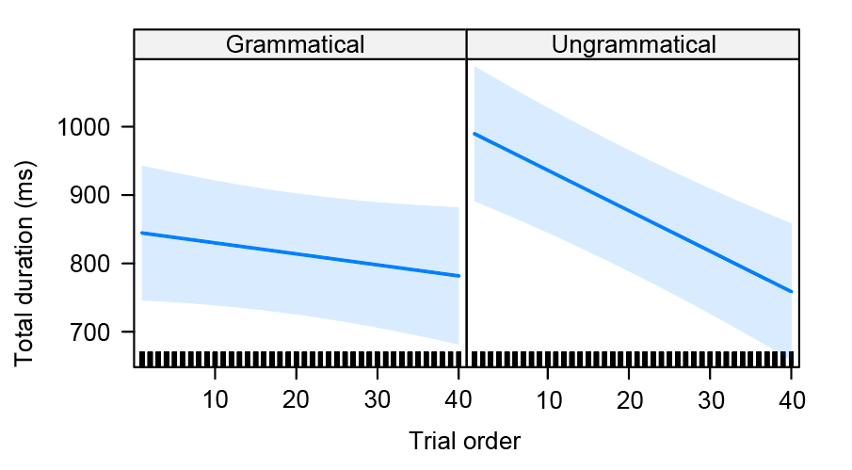

Figure 7. Regression path duration on the subject: Effect plot of grammaticality and trial order

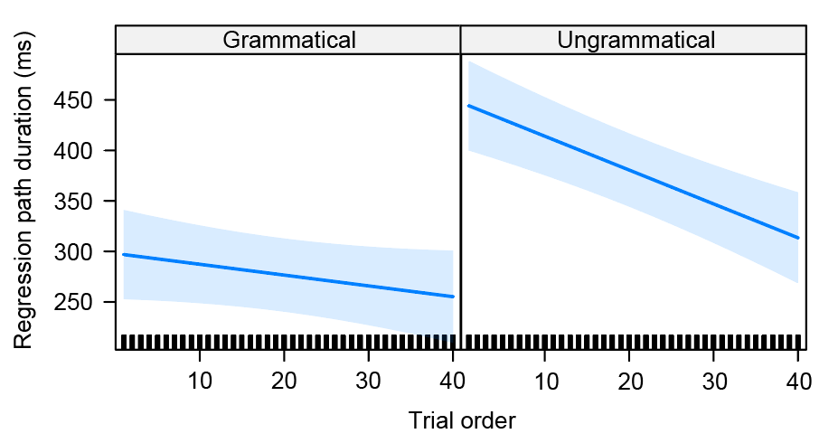

Figure 8. Total duration on the subject: Effect plot of grammaticality and trial order

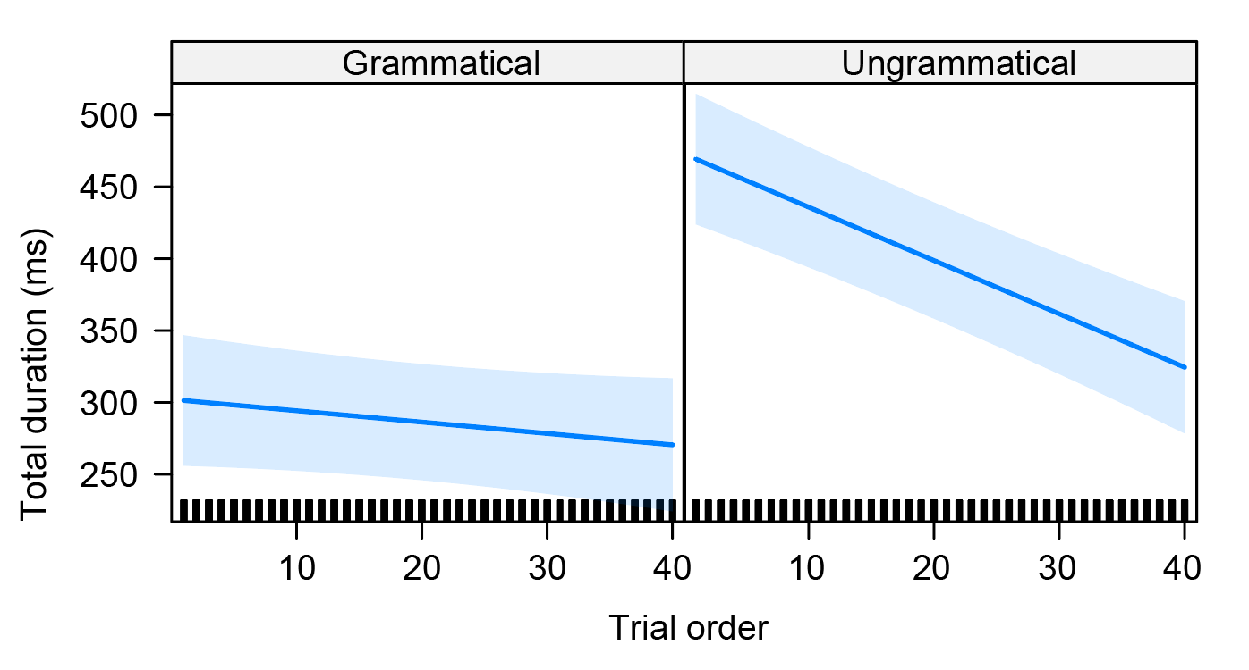

Figure 9. Regression path duration on the verb: Effect plot of grammaticality and trial order

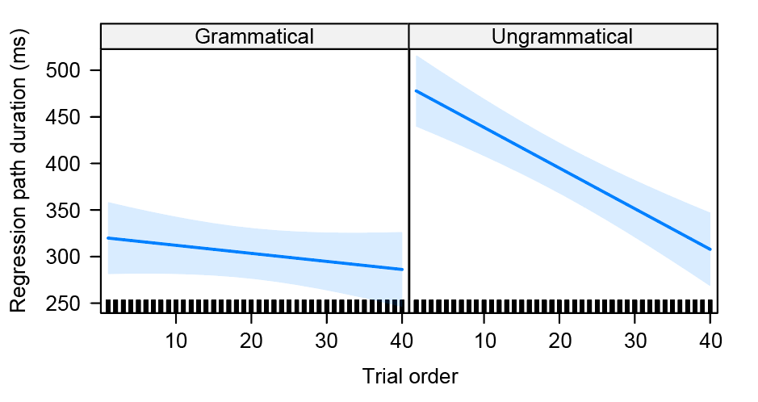

Figure 10. Total duration on the verb: Effect plot of grammaticality and trial order

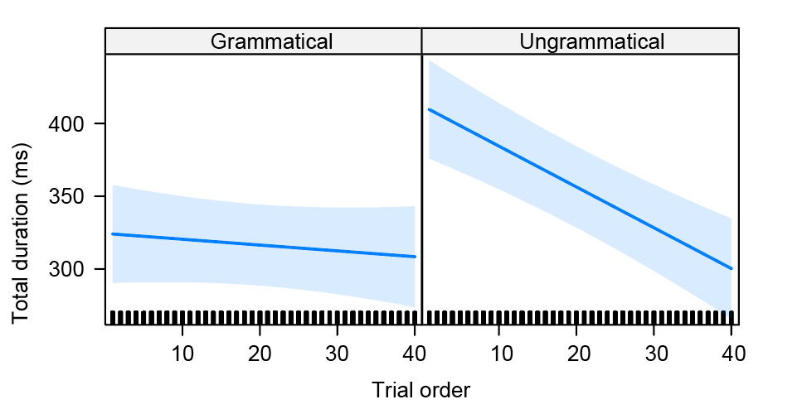

Figure 11. Total sentence reading times (ms) for each participant

